In relation **A**, we are loading the dataset using CSVExcelStorage because of its effective technique to handle double quotes and headers.

Below is the screenshot for both step and output of above process.

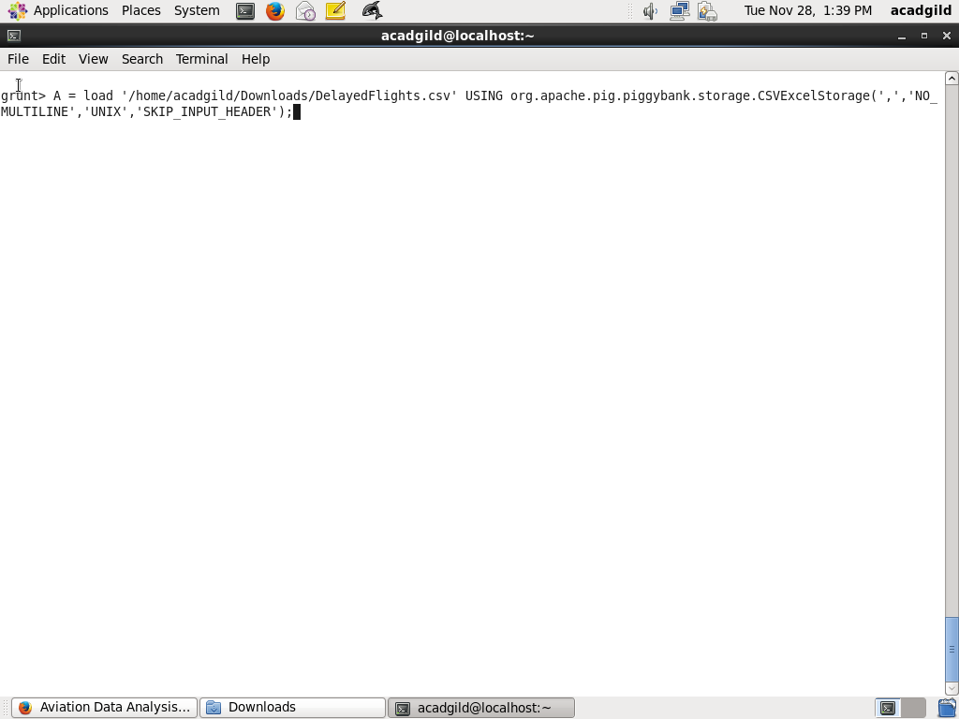

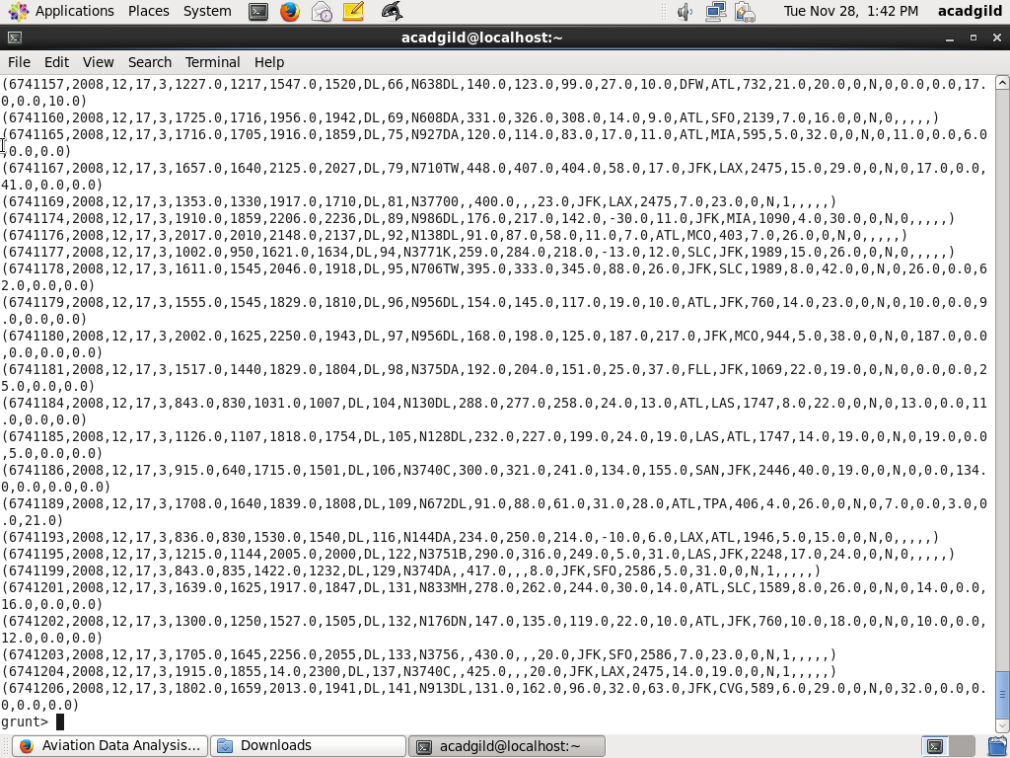

In relation **B**, we are generating the columns that are required for processing and explicitly typecasting each of them.

Below is the screenshot for both step and output of above process.

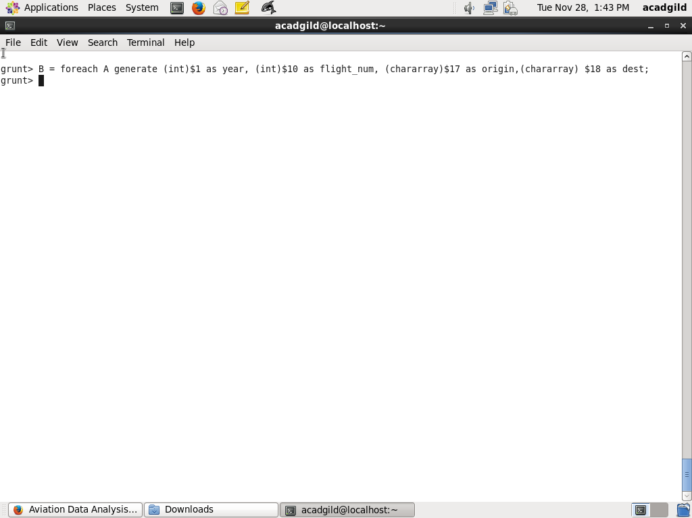

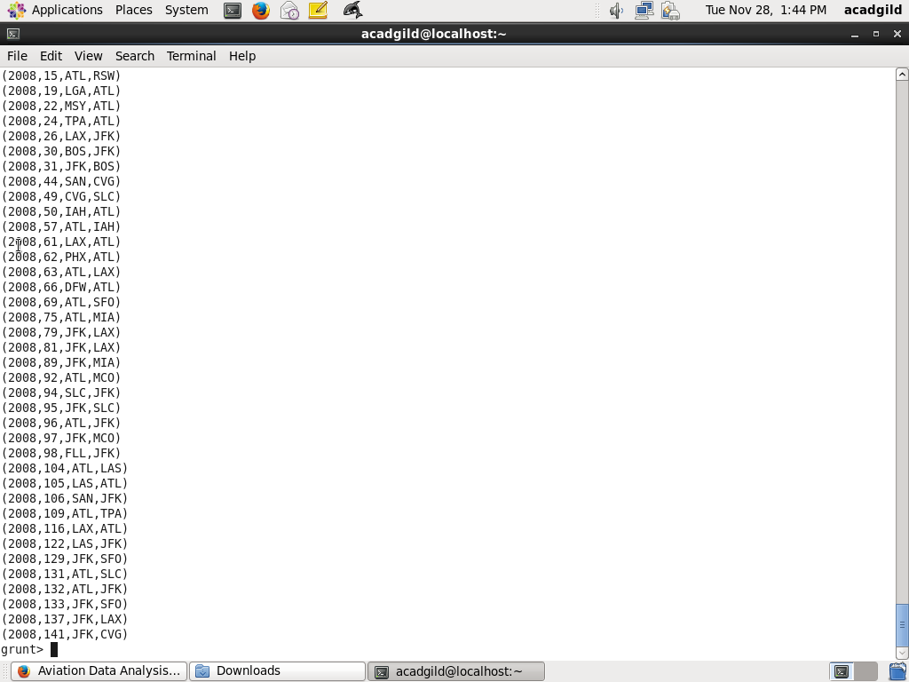

In relation **C**, we are filtering the null values from the “dest” column

Below is the screenshot for both step and output of above process.

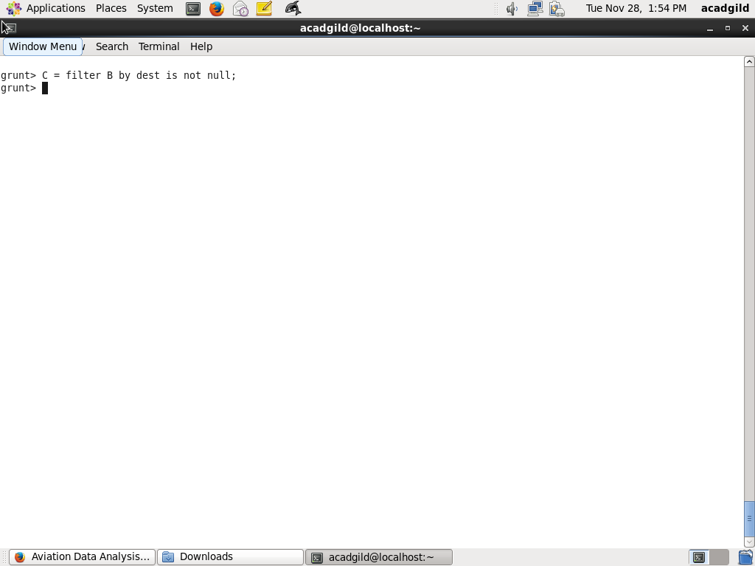

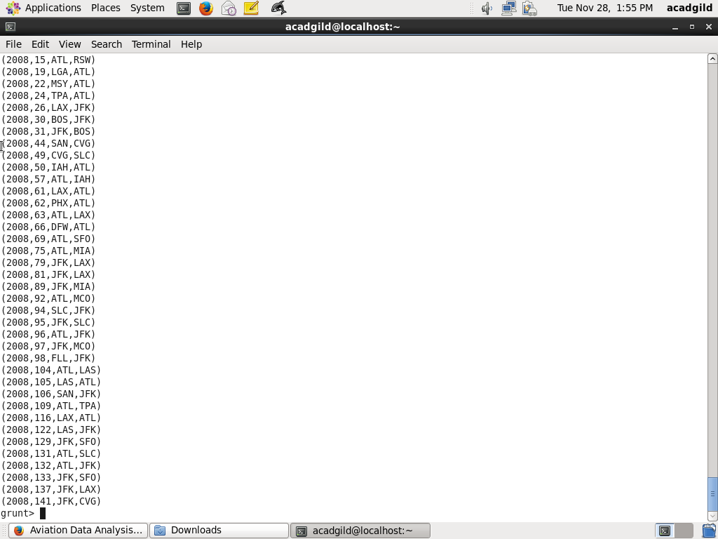

In relation **D**, we are grouping relation C by “dest.”

Below it screenshot of step and derived output

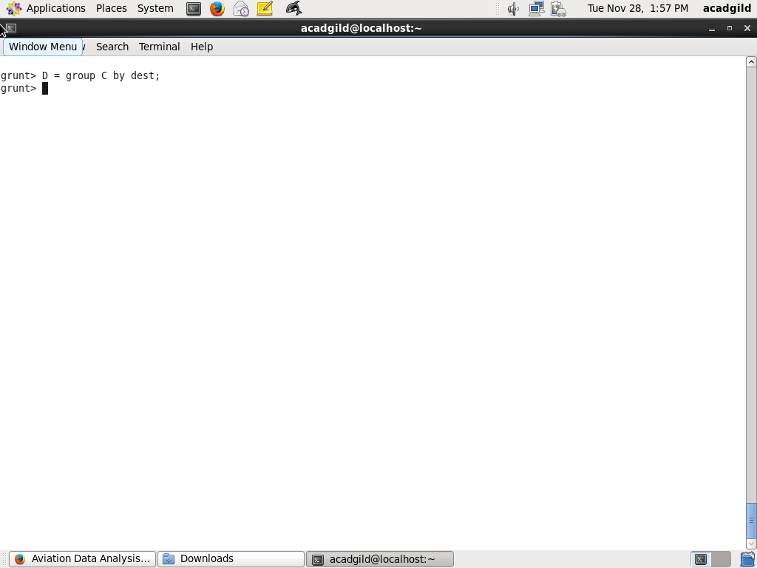

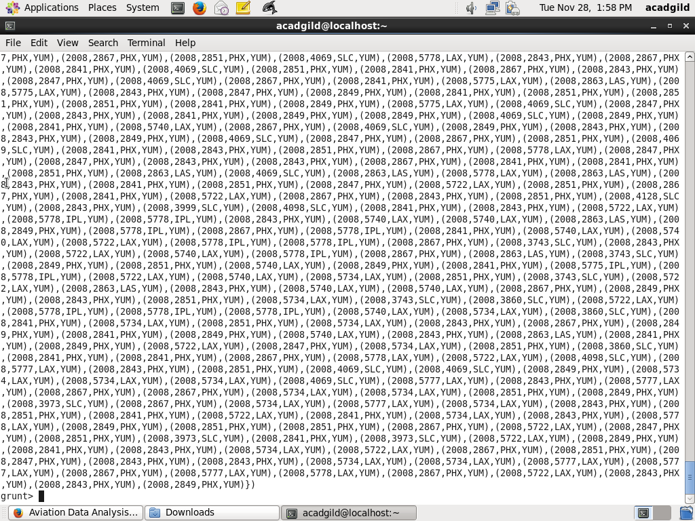

In relation **E**, we are generating the grouped column and the count of each.

Below it screenshot of step and derived output

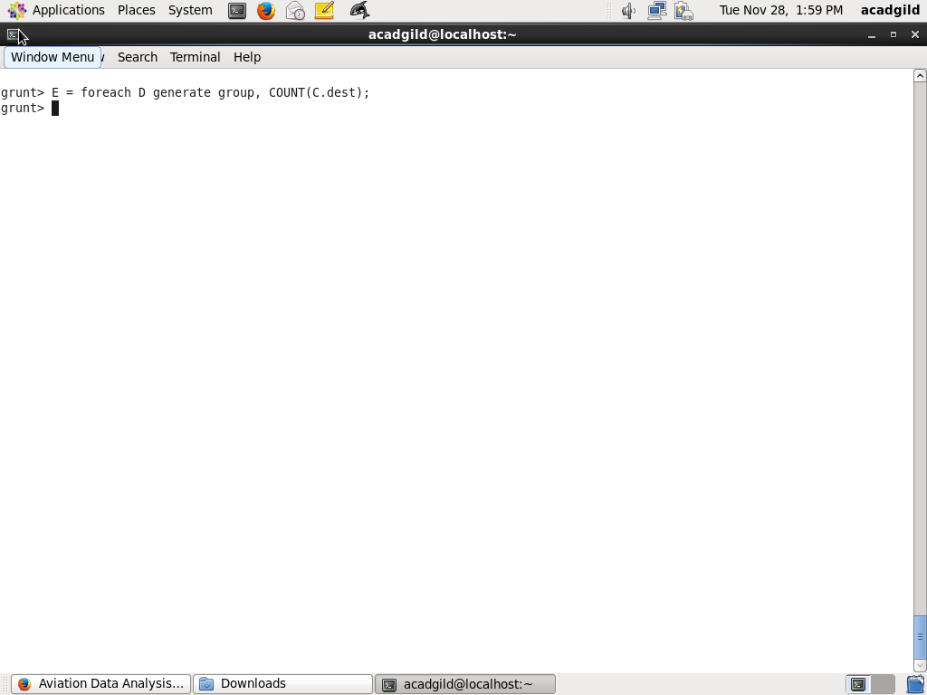

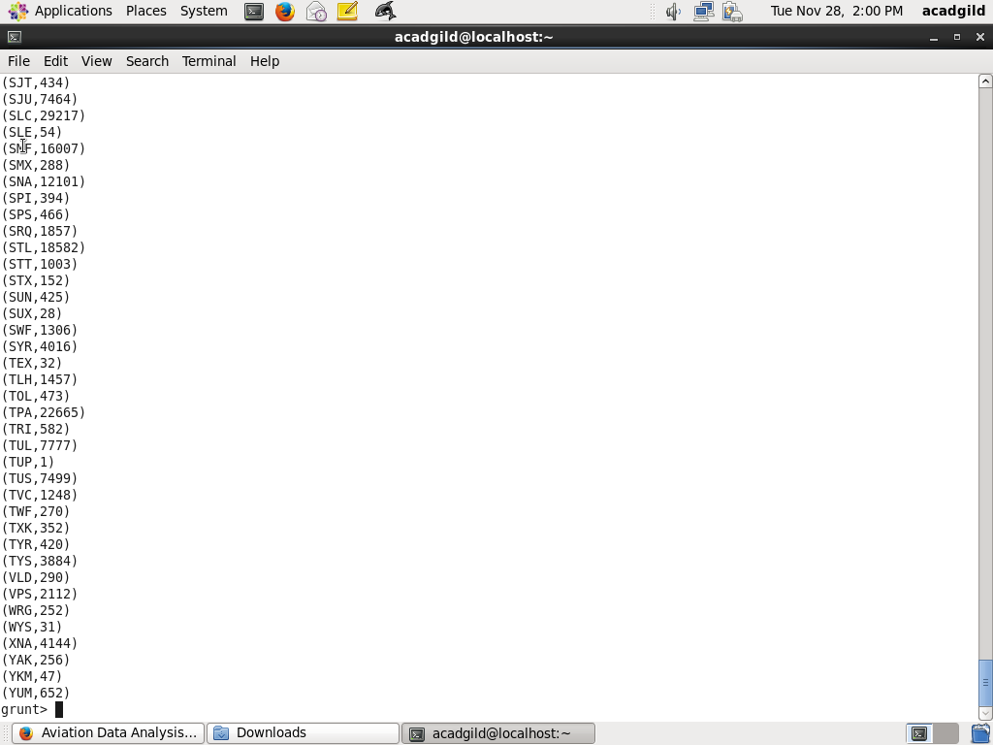

Relation **F** and **Result** is used to order and limit the result to top 5.

**Below it screenshot of step and derived output**

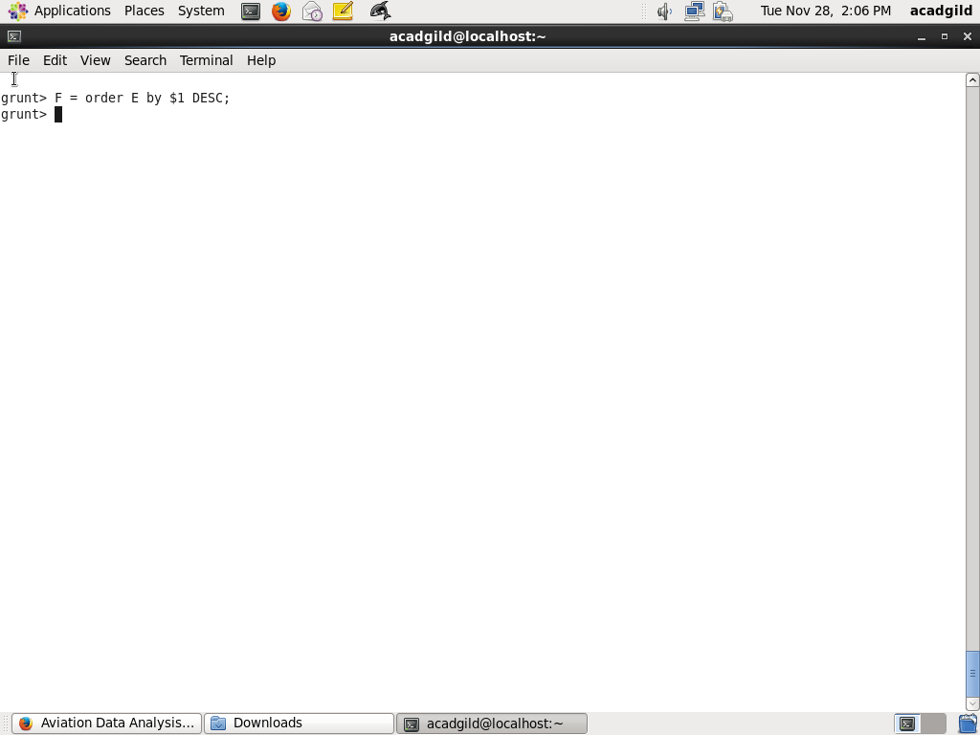

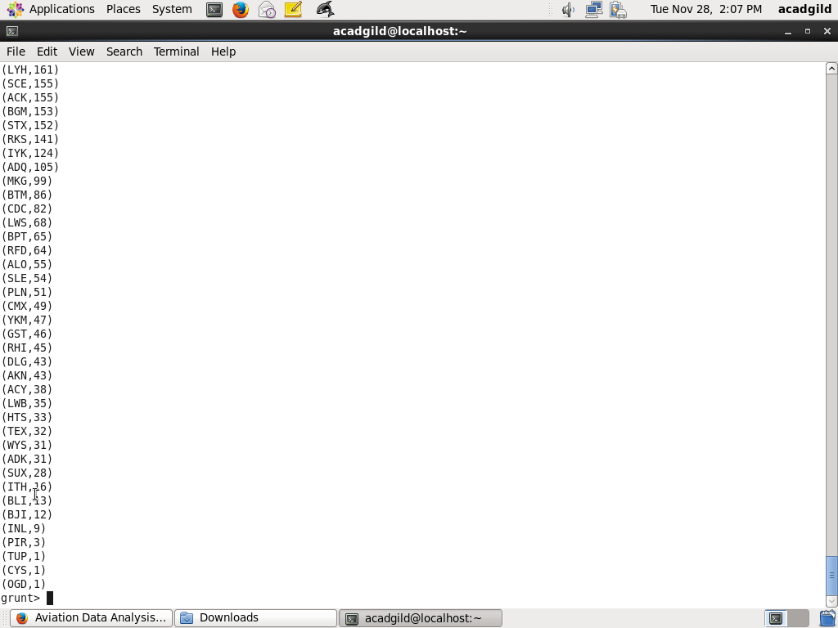

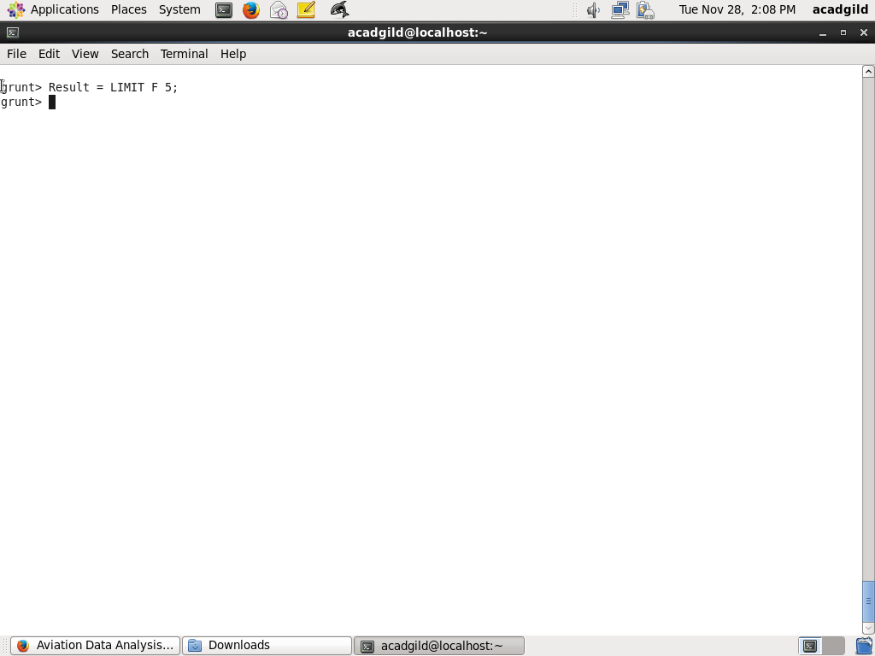

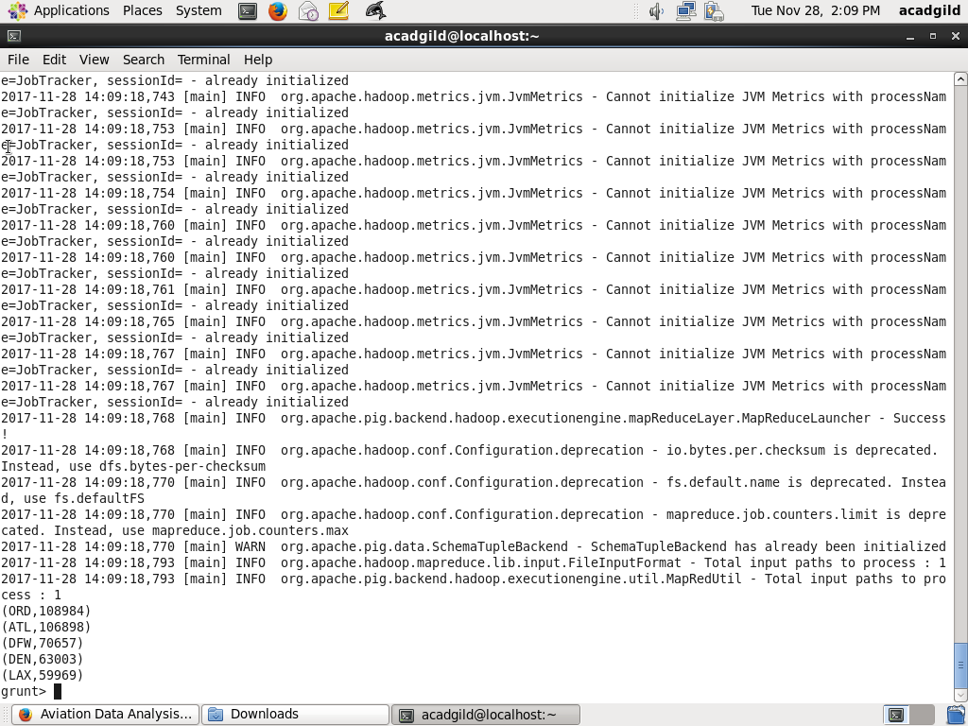

In relation **A1**, we are loading another table to which we will look-up and find the city as well as the country.

**Below it screenshot of step and derived output**

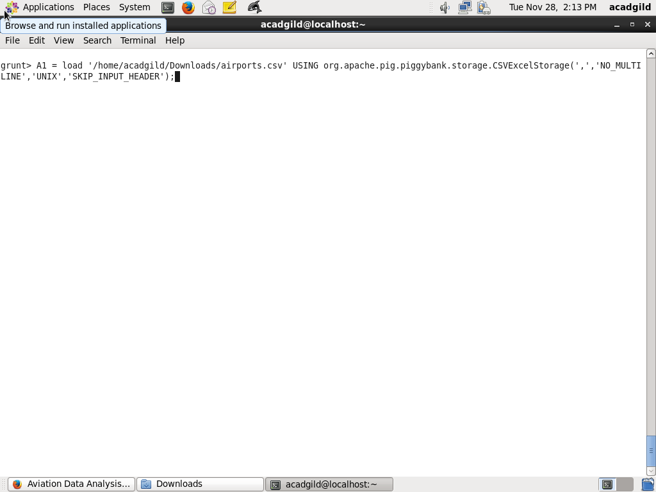

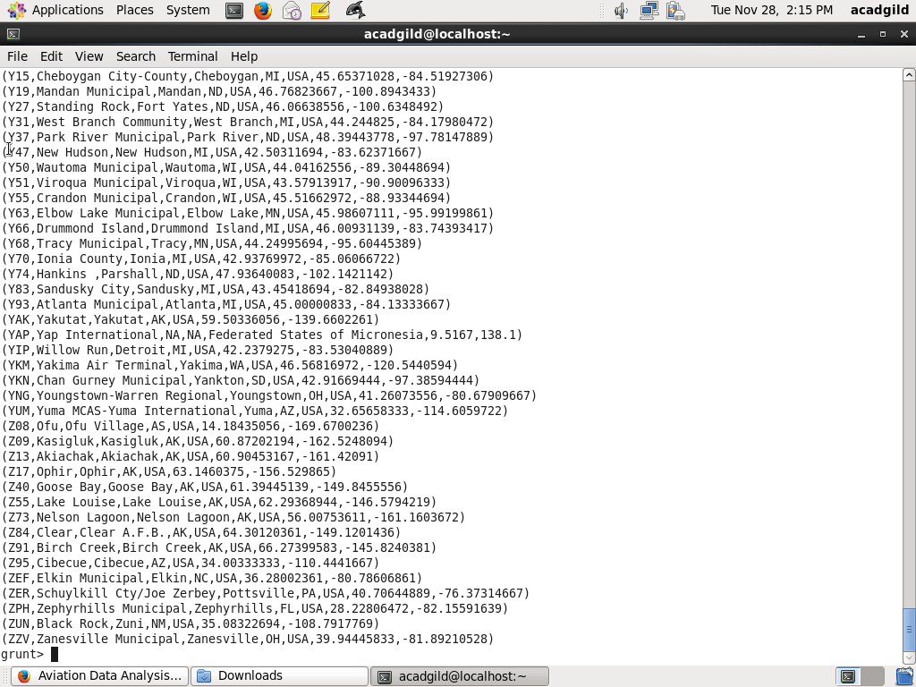

In relation **A2**, we are generating dest, city, and country from the previous relation.

**Below it screenshot of step and derived output**

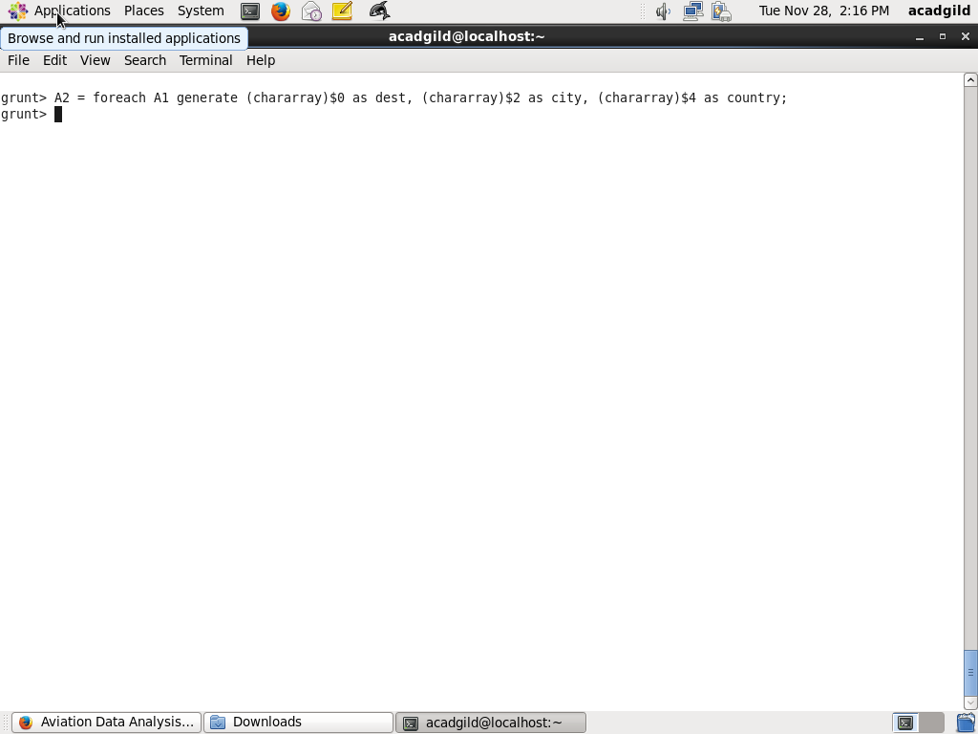

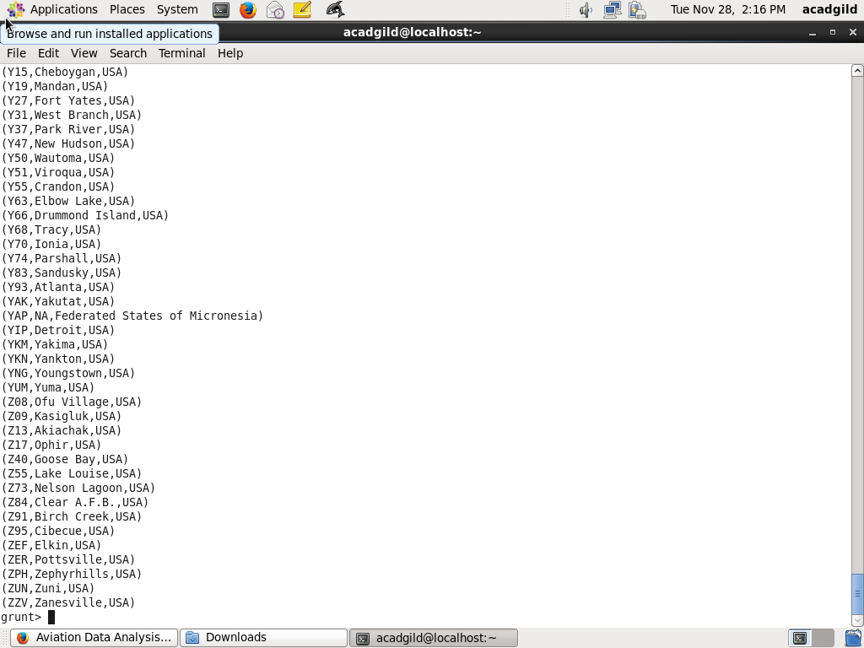

In relation **joined_table**, we are joining Result and A2 based on a common column, i.e., “dest”

**Below it screenshot of step and derived output**

